Jevonte Frederick
6/17/2026
SNHU
Artifact Three
For this artifact, I enhanced a project from a computer science course focused on software testing. For this assignment, we were tasked with creating an object and service class for contacts, tasks, and appointments. Each had requirements for the fields of each object having character limits and no fields being initialized as null. The service classes additionally had requirements for each service class to handle exceptions, such as not allowing duplicate IDs. I was required to design unit tests to ensure each requirement was met in the code for objects and their service classes.
My enhancement to the project was to implement a database. The original artifact used a hashmap for each service to store objects. I used SQLite as the JDBC to implement a central database called contacts.db. I added a program driver class to the project to initialize the database:
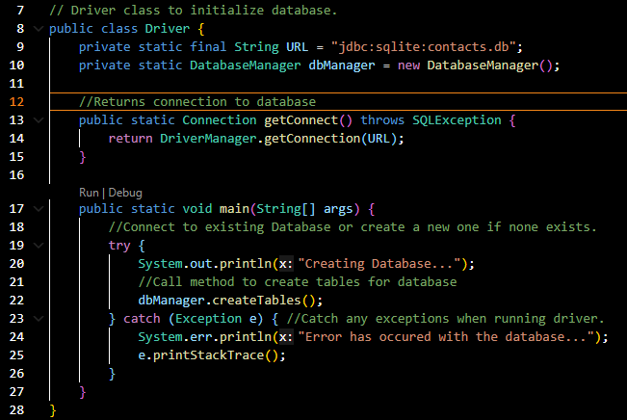
From this code snippet, the driver class creates the database and uses a DatabaseManager object to create the tables. The following is a part of my DatabaseManager class code:
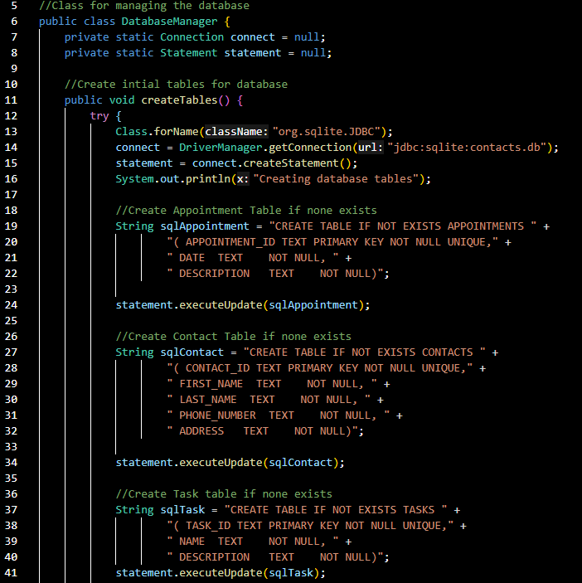
This is a snippet of the code from my DatabaseManager class to create the tables. Instead of a hashmap in the original artifact, a table is created for contacts, tasks, and appointments with their respective fields. The manager connects to the database and creates the three tables if none exists when the main program driver is run. Following this, I designed a Data Object Access (DAO) class for each object for the database operation code of each table. It follows the pattern of the artifact’s original requirements, such as the AppointmentDAO only needing methods to add or delete appointments:
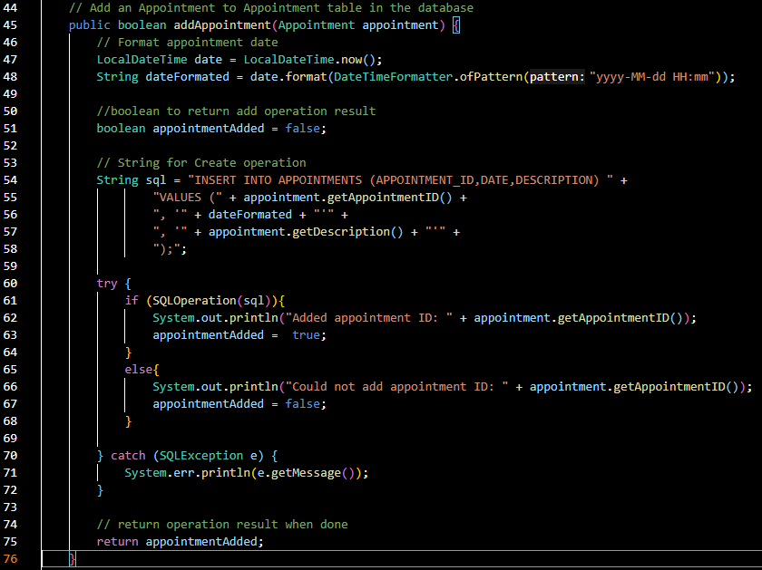
This is an example of my AppointmentDAO method to add an appointment to the appointment table. This method is called by the AppointmentService class where it will call the SQLOperation method passing the specific SQL operation as a string to perform the executeUpdate() method on the database. The method then returns the result of the operation as a boolean to determine if it was successful. The SQL operation will throw an SQLexception if a duplicate ID is trying to be added to the table. This keeps the enhancement consistent with the original requirements of the artifact.
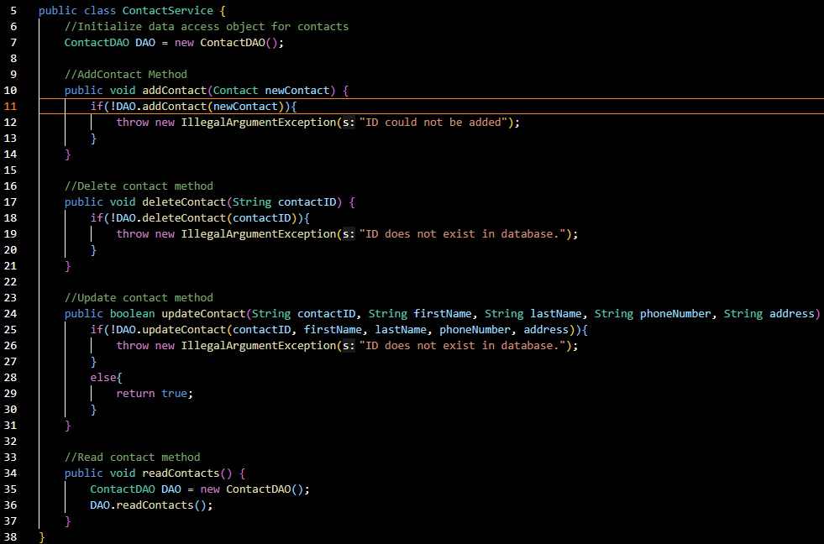
This snippet of my ContactService file shows the changes I made to the service classes. They no longer use a hashmap and use the DAO object to perform the operations to the database. I have additionally implemented a read() method for each object that will return all data from the table for basic functionality to output the database content. The methods to add, delete, and update, throw exceptions when the SQL operation fails or no updated results are returned. This allows the service tests from the original artifact to work as intended in this enhancement.
Ultimately, I chose this artifact because I saw potential in iterating this project to have more functionality. Its focus was only on practicing software testing, so the functionality of using the service class for more than constraint verification was secondary. I saw that such a program managing multiple object classes could be enhanced to have a central database to store its data. This enhances the artifact to be closer to real-world software with the ability to store contacts, appointments, and tasks beyond runtime. This is good to show my ePortfolio because it shows knowledge of databases and how to add complexity to programs. My enhancement makes the artifact closer to database module software that an organization such as a repair store would use to manage tasks, appointments, and their contacts. The modular design of my enhancement allows it to be iterated further to power a website with a server-side database that uses authorization and authentication for access.
With this, I believe I have met the outcome of using well-founded and innovative techniques and tools to deliver value. This is because I recognized how standard a database is to manage the storage of multiple objects such as in this artifact. I also accomplished employing strategies for building collaborative environments for diverse audiences. This is because I enhanced this artifact with business goals in mind. The goal was to make this artifact like lightweight software that is now scalable to power a business-backing database. My design is intended to allow collaboration in building professional software. It is documented for developers and other stakeholders to understand what it does and how it works. The unit tests help display how the code works, which I made sure are still functional in the enhancement. So, it shows my business-oriented problem solving because databases are an industry standard for managing data efficiently to stay competitive in the modern day. Being able to implement a database for software that originally only used Java data structures is a good showcase of database knowledge and application. It also shows my growth as I was not familiar with the utilization of database software when I first designed this artifact. So, this also helps show my commitment to self-improvement by applying new techniques I have learned to earlier works in my computer science career path.
The development of this enhancement was also challenging as I had to learn how to use SQLite from scratch. I have experience with databases such as MongoDB from modifying starter code, but I had to implement the database on my own for this enhancement. This was valuable experience deploying database functionality from scratch when the artifact originally had none. I believe it has helped me show my skills in problem solving. To store multiple objects with different attributes, one would want a database for effective management. I have solved this problem by introducing database storage while overcoming the challenges of reworking old code to be compatible with databases. Artifacts such as this have inspired me to continue introducing increasingly complex industry practices to old software to test my abilities as a developer and software engineer.

